Video Format:
0:00-0:07
- This is a common chart floating around on the internet. It shows the price of childcare increasing over time.

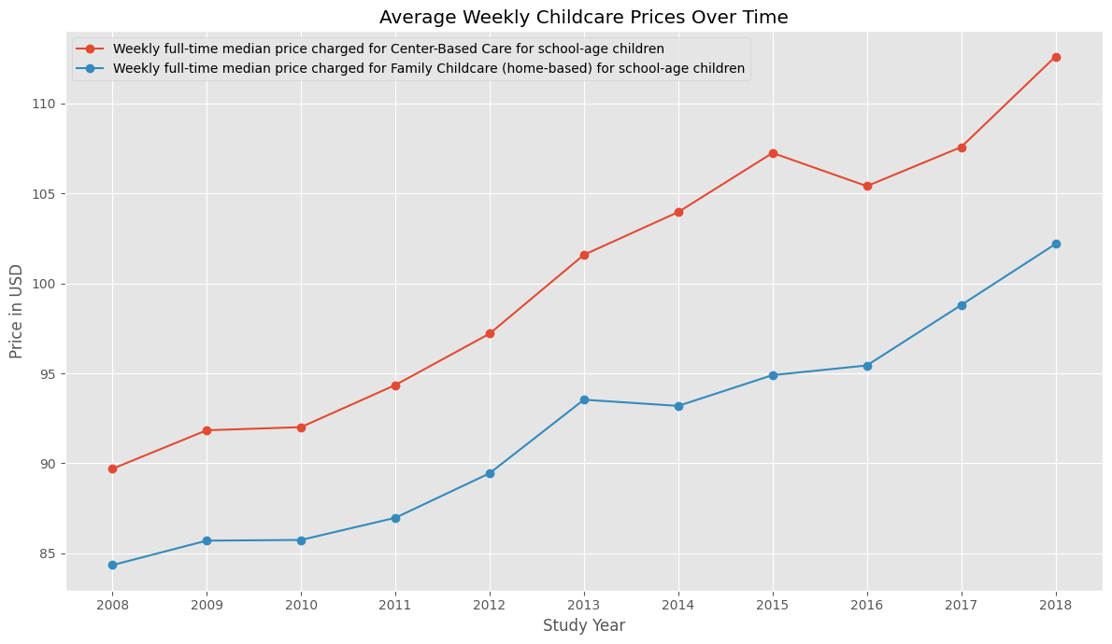

0:07-0:15
- And while this is true, the median incomes over the last decade have also increased, and childcare takes up about the same amount of household income as it did back then.
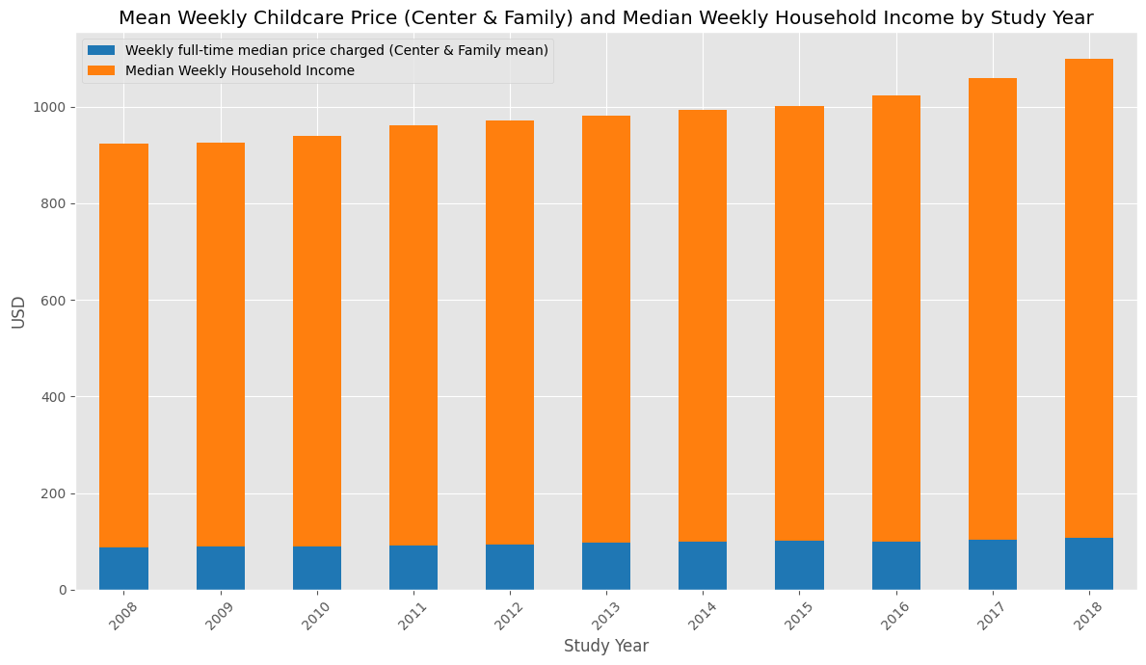

0:15-0:25
- The rates fluctuate over time, but their increases have zero correlation to female unemployment.

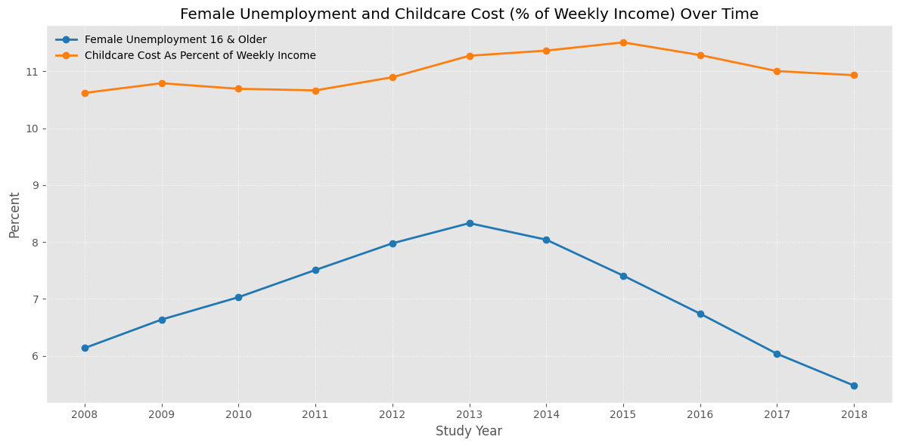

0:25-0:35
- It’s important to recognize these trends over time and care about the cost of childcare, but the fact is, childcare is already affordable for most households. Many are shocked when they put their infants into childcare, but the truth is 0 to 23 months are the most expensive. As children get over, their care becomes less expensive.

